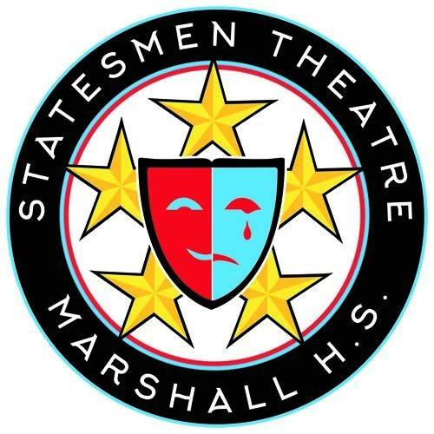

For Immediate Release: October 26, 2018

Contact:

George C. Marshall High School Presents Geek!
The Intersection of Cosplay and Anime in a Stunning Theatrical Production

Falls Church, Virginia – Steampunk armies, timekeepers, Jedis and elves are part of a strange and wonderful cosplay subculture in Statesmen Theatre’s fall production of Geek! from November 8-10, 2018. Set for adventure at an Inferno-esque anime convention in Ohio, this fantasy-fueled play addresses serious issues like suicide and bullying with storytelling, technology, costumes and tremendous humor that have universal appeal. The show features extensive fight scenes choreographed by Vato Tsikurishvili, star of Synetic Theatre’s recent Helen Hayes-recommended Sleepy Hollow.

As an added dimension, Statesmen Theatre will be collaborating with the anime club at Marshall to present Mar-Con, the Anime Club’s onsite mini-convention before their Saturday November 10th matinee, featuring karaoke, a costume contest, video games, anime viewing and anime-themed treats for sale. Admission to Mar-Con is free, and the event will run from 10:00 a.m. to 2:00 p.m. in the Marshall Cafeteria and Black Box (at Door 13). Come for Mar-Con, celebrate anime culture with fellow geeks, and stay for the matinee of Geek! at 2:00 p.m. All area otaku (anime/manga fans) are invited and encouraged to come in costume.

“As a new member of the Statesmen Theatre community, I’m impressed with the talent and hard work of the actors and theatre technicians here at Marshall High School,’” said theatre director Bernie DeLeo, who is making his Marshall High School directing debut. “I love Geek! so much. It celebrates imagination, friendship and inclusivity – it’s an incredible show that you won’t want to miss!”

DeLeo comes to Marshall High School with over 10 years of experience as an FCPS Drama Director and most recently from West Springfield High School. Before that DeLeo worked for 20 years in the entertainment industry. He was an independent film producer, a screenwriter, sitcom writer, actor, and script reader at HBO, Fine Line Features, Broadway’s Circle in the Square Theatre, and other regional theatres.

Geek! opens on Thursday, November 8, at 7:30 pm with additional shows on November 9 at 7:30 pm, and two shows on November 10 at 2:00 pm and 7:30 pm. The show will be at George C. Marshall High School’s main auditorium at 7731 Leesburg Pike, Falls Church, VA 22043. Tickets are $8 for students / seniors and $12 for adults - and can be purchased online at www.statesmentheatre.org or the Box Office before each performance. Students who show up in costume can buy tickets at the door for $5. Visit http://statesmentheatre.org for more information.

###

